ASSIGNMENT 4 WOKWI PROGRAM

|  |  |
| --- | --- |
| Assignment Date | 27 OCT 2022 |
| Student Name | SUJIN S |
| Student Roll Number | 727819TUCS212 |

PROGRAM

Smart Waste Management System for Metropolitan Cities

ASSIGNMENT 4:

Write code and connections in wokwi for ultrasonic sensors.Whenever distance is less than 100 cms send "alert" to ibm cloud and display in device recent events.Uplode document with wokwi share link and images of ibm cloud.

CODE:

#include <WiFi.h> #include <PubSubClient.h> WiFiClient wifiClient; String data3;

#define ORG "ztcz45"

#define DEVICE_TYPE "naveen" #define DEVICE_ID "naveen123" #define TOKEN "123456789"

#define speed 0.034

#define led 14

char server[] = ORG ".messaging.internetofthings.ibmcloud.com"; char publishTopic[] = "iot-2/evt/Data/fmt/json";

char topic[] = "iot-2/cmd/home/fmt/String"; char authMethod[] = "use-token-auth";

char token[] = TOKEN;

char clientId[] = "d:" ORG ":" DEVICE_TYPE ":" DEVICE_ID;

PubSubClient client(server, 1883, wifiClient);

void publishData();

const int trigpin=5; const int echopin=18; String command; String data="";

long duration; float dist;

void setup()

**{**

Serial.begin(115200); pinMode(led, OUTPUT); pinMode(trigpin, OUTPUT);

**…**

[10:32 pm, 23/10/2022] Gogul B.E CSE: }

void mqttConnect() {

if (!client.connected()) {

Serial.print("Reconnecting MQTT client to "); Serial.println(server); while (!client.connect(clientId, authMethod, token)) { Serial.print(".");

delay(500);

**}**

initManagedDevice(); Serial.println();

**}**

**}**

void initManagedDevice() { if (client.subscribe(topic)) {

// Serial.println(client.subscribe(topic)); Serial.println("IBM subscribe to cmd OK");

**}** **else** **{**

Serial.println("subscribe to cmd FAILED");

**}**

**}**

void publishData()

**{**

digitalWrite(trigpin,LOW); digitalWrite(trigpin,HIGH); delayMicroseconds(10); digitalWrite(trigpin,LOW); duration=pulseIn(echopin,HIGH); dist=duration*speed/2; if(dist<100){

String payload = "{\"Normal Distance\":"; payload += dist;

payload += "}";

Serial.print("\n"); Serial.print("Sending payload: "); Serial.println(payload);

if (client.publish(publishTopic, (char*) payload.c_str())) { Serial.println("Publish OK");

**}**

**}**

if(dist>101 && dist<111){

String payload = "{\"Alert distance\":"; payload += dist;

payload += "}";

Serial.print("\n"); Serial.print("Sending payload: "); Serial.println(payload);

if(client.publish(publishTopic, (char*) payload.c_str())) { Serial.println("Warning crosses 110cm -- it automaticaly of the loop"); digitalWrite(led,HIGH);

}else {

Serial.println("Publish FAILED");

**}**

**}**

**}**

void callback(char* subscribeTopic, byte* payload, unsigned int payloadLength){ Serial.print("callback invoked for topic:");

Serial.println(subscribeTopic); for(int i=0; i<payloadLength; i++){ dist += (char)payload[i];

**}**

Serial.println("data:"+ data3); if(data3=="lighton"){ Serial.println(data3);

digitalWrite(led,HIGH);

**}**

data3="";

**}**

out put:

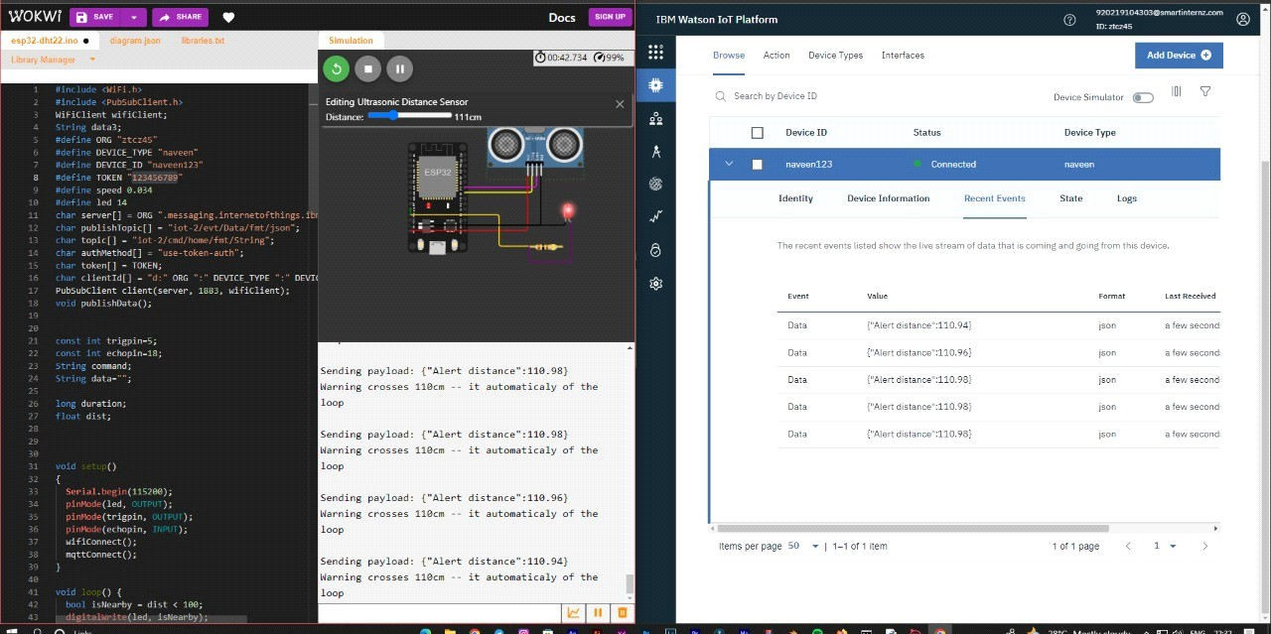

# When distance under 100 cm it wil show normal distance.

Publish OK

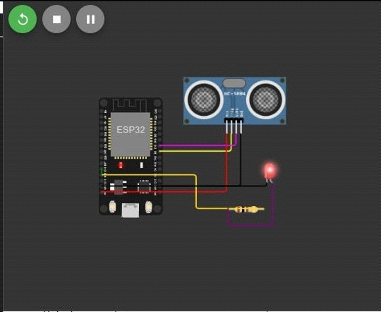

Sending payload:{"Normal Distance'':89.95} Publish OK

Sending payload: {''Normal Distance'':89.95} Publish OK

Sending payload:{"Normal Distance'':89.95} Publish OK

Sending payload: {''Normal Distance'':89.95} Publish OK

Sending payload:{"Normal Distance'':89.95} Publish OK

# When distance cross 100 cm it wil show ALERT worning message distance

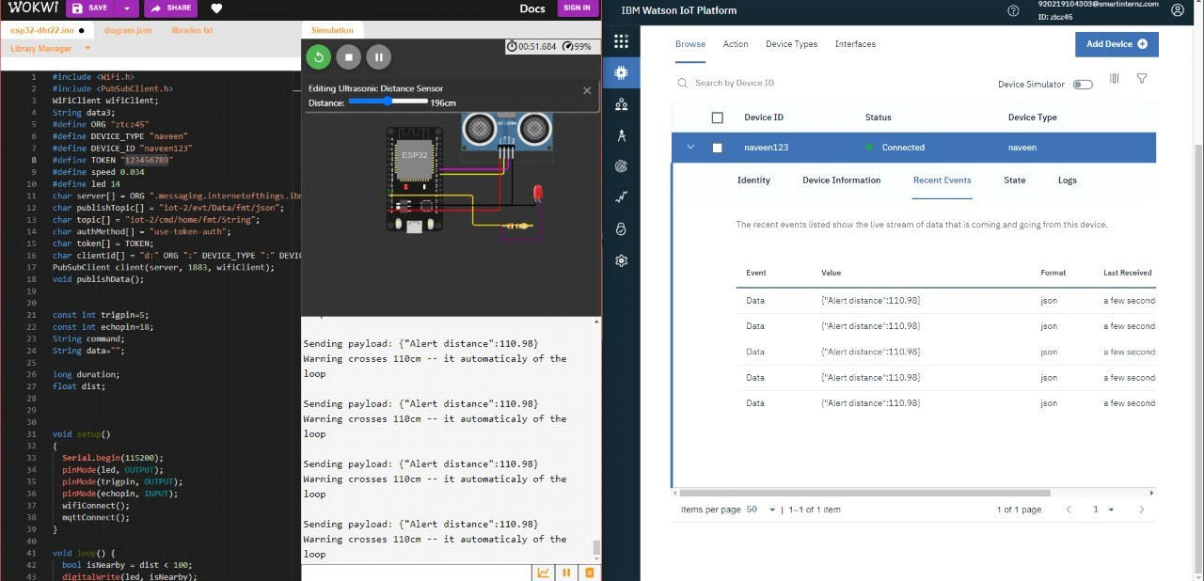

1. **When** **it** **cross** **above** **110** **cm** **it** **today** **move** **to** **iff** **state** **once** **it** **reduce** **to** **11o** **it** **on** **again**

# Connection information:

Basic conntection information about this device.

Organization ID : ztcz45

Device Type : naveen

Device ID : naveen123 Authentication Method : use-token-auth

Authentication Token : 123456789

